Ai project report
N006 – Mansi Bharambe
N007 – Jay Bharatia
N015 – Parvi Dev
N027 – Arnav Iyer
Project Overview
An AI-powered voice-based symptom checker that diagnoses diseases and provides personalized medical recommendations using Natural Language Processing and token-based pattern matching algorithms. The system employs Web Speech API for voice input, converts spoken symptoms into text tokens, and matches them against a curated database of 62 diseases using fuzzy string matching and sequence similarity algorithms. GPT-4o-mini generates natural confirmation questions to improve diagnostic accuracy, while a confidence scoring system (0-100%) validates predictions. The platform includes a patient portal with real-time voice interaction and text-to-speech feedback, alongside a doctor dashboard for managing patient callbacks with status tracking (Pending → Called → Completed). Backend powered by Flask API integrates OpenAI's language model for conversational flow, with structured JSON-based recommendation engine providing medications and home remedies for each diagnosed condition.
Process
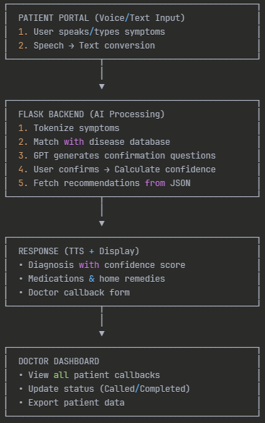
Algorithm Used
- Tokenization: Split symptoms into words
- String normalization: Lowercase, remove punctuation
- Token set matching: Compare user symptoms with disease database
Ai-technologies used
- Frontend: HTML5, CSS3, JavaScript
- Backend: Python, Flask, OpenAI-API
- AI/ML: NLP (tokenization, fuzzy matching), Speech APIs
- Data: CSV, JSON

